Bugs 1, 2, and 3 Investigation

Legend: **blue** words are classes, **green** words are methods, and **purple** words are instance variables. (If a word is not coloured, that means it is being used in its natural English sense).

# Description

Whenever the player makes a match, he is not paid out correctly according to the rules sheet.

* When he makes one match, he just gets his money back instead of winning an amount equal to his bet.
* When he makes two matches, he wins only the amount that he bet, not twice the amount he bet.
* When he makes three matches, he wins only twice what he bets, not three times.

The reason all three of these scenarios are in the same investigation document, is because our initial hypothesis (before doing any investigation or static review) is that they all have the same cause, and therefore will all be resolved with the same change. Spoiler alert: if this document still exists at the time of marking, then this hypothesis turns out to be true (or otherwise they would have been split up into separate documents).

# Static Review

The first place to look in during main where the winnings get calculated. Looking here:

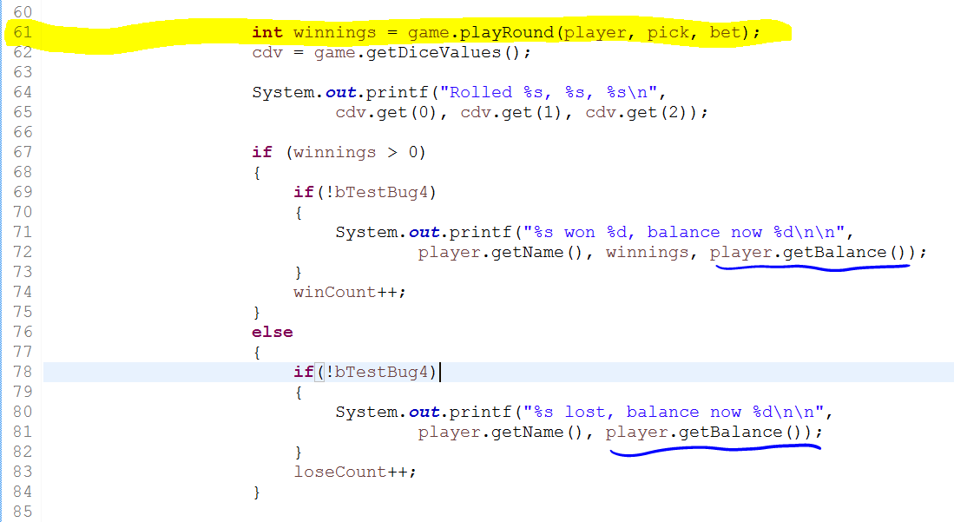

We see that winnings are calculated by Game’s playRound. After that, they are only displayed to the screen along with the player’s balance (from Player’s getBalance).

Let’s look at an example output to see what might be wrong.

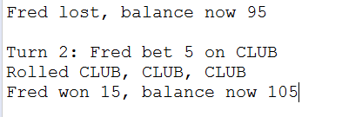

We can see that the winnings amount displayed is correct (15 = 5X3 and there were three matches) but the balance is incorrect (95+15 = 110, not 105).

There are two possibilities. Either playRound is not changing the player’s balance correctly, or getBalance is not displaying the balance correctly (and maybe it is correct internally). If getBalance was not displaying the amount correctly, and it was off by 5 in every case, we would expect the first line in the above screen snip to also be 5 off (and thus the change in balance would look correct – 5 off on both cases for a 15 total change). But it isn’t. Therefore, it’s can’t be getBalance’s fault.

So that leaves us just with playRound. Let’s have a look.

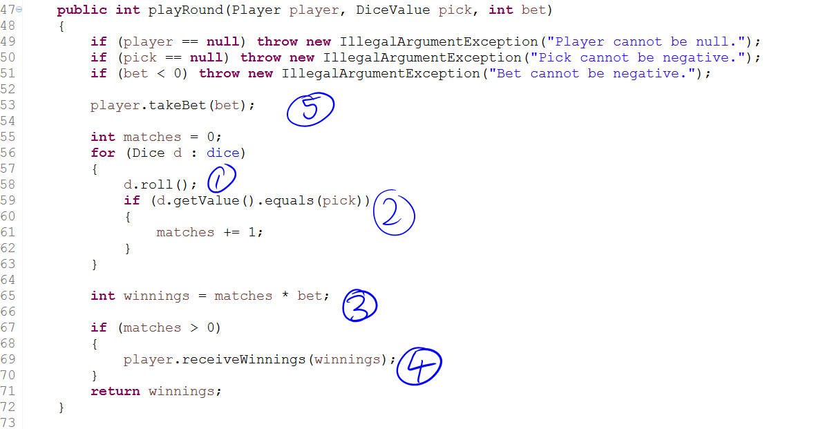

This is the whole playRound function. At (1) the dice are being rolled, and from fixing Bug 4 we know that this works as intended. At (2) we are comparing the value of the dice with the pick. One hypothesis is that this works fine. We can test it to confirm (see next section). At (3), if (2) produces the correct number of matches there is no reason why this wouldn’t work (both matches and bet are ints, so there should be no issue with them being multiplied). At (4), the method receiveWinnings adds the winnings onto the player’s balance. This has been unit-tested in PlayerTest so should work:

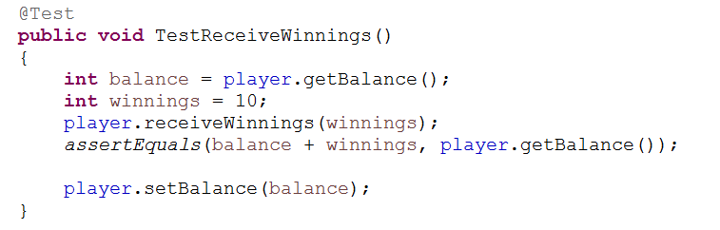

As you can see, the balance is recorded before anything happens, the winnings are set, the method is called, and there is an assert that the player’s balance has changed as expected. Just in case there is any wriggle-room for doubt, we will make this a hypothesis and test it (that the player’s balance increases by the ‘winnings’ amount).

So then if everything we just looked at works as expected (assuming testing passes our two hypotheses so far), where, then, does the bug come from? It must be at number (5), with the takeBet method. I don’t even know what this is for, so let’s have a look:

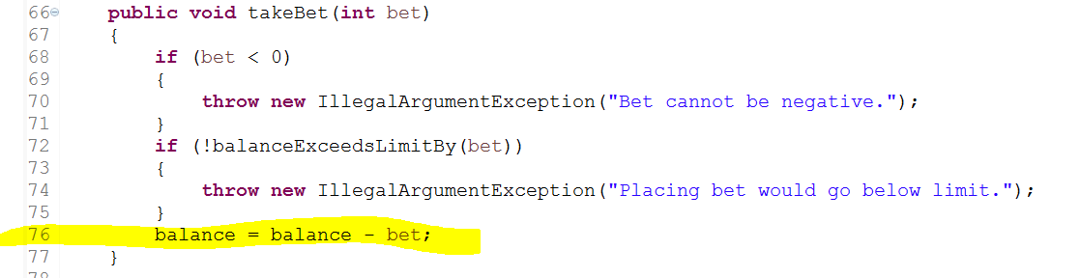

The program proceeds in normal fashion each time we have run it, so we should be able to presume that neither of the conditions for exceptions being thrown are ever met. Therefore, we can concentrate on the last line (highlighted) and treat it as the only line in the method.

So, takeBet deletes one lot of the bet amount from the player’s balance.

We can see immediately what is wrong here. Looking at (3) from the playRound screen snip, the winnings are calculated as number of matches times the bet amount. According to the rules, this is correct – this amount is meant to be added onto the player’s balance from before the round. However, the balance is changed before the winnings are added on. One lot of bet is removed before the winnings are added on, leading to the player receiving one less lot of bet for each win. For example, one match results in no change to balance (should have increased by one lot of bet, so is one lot of bet worse off), two matches results in one lot of bet added to the balance (should be two lots, so again one lot worse off), and three matches results in two lots of bet added to the balance (instead of three).

If our guesses are right, then all three of these hypotheses need to be tested true:

1. The value of the dice is compared successfully to pick and the correct number of matches is calculated.
2. The player’s balance correctly increases by the winnings amount after receiveWinnings is executed.
3. The balance is incorrect at the time of executing receiveWinnings.

# Hypothesis Testing

# Resolution

# Conclusion